National Workshop  on  Utilization of Engineering Standards  February 14, 2013  (under TEQIP-II)  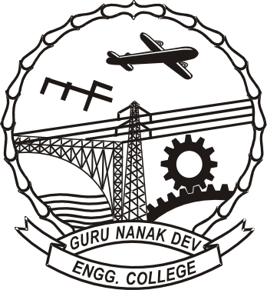  Organized by  Department of Mechanical Engineering  Guru Nanak Dev Engineering College, Ludhiana  (An autonomous college under UGC Act)  in collaboration with  Bureau of Indian Standards   |  | The standards play great role in industries and engineering education. For maintaining consistent quality of the product, the standards have great significance. At present, the use and awareness of various standard needs to be reviewed. In the view of ever-increasing expectations of the society, more standards need to be developed and implemented in the manufacturing of products with a view to bring customer satisfaction.  Guru Nanak Dev Engineering College has collaborated with Bureau of Indian Standards for organizing an awareness program to promote the use of Indian standards for manufacturing of products and services as well. The major objective of the present Workshop is to create awareness among academia regarding the utility of engineering standards. Faculty members from AICTE recognized engineering colleges, and UG/PG students of Engineering and Technology are also eligible to participate in the Workshop.  10.00 - 10.30 a.m. Registration  10.30 - 11.00 a.m. Inauguration  11.00 - 11.15 a.m. Tea break  11.15 - 12.15 p.m. Technical Session-I  12.15 - 01.15 p.m. Technical Session-II  01.15 - 02.15 p.m. Lunch Break  02.15 - 03.15 p.m. Technical session –III  03.15- 04.00 p.m. Technical Discussion  04.00 - 04.30 p.m. Valedictory function |  | Patron  Dr. M.S. Saini,  Director  Chairman  Dr. Sehijpal Singh  Head of Department  Co-Chairman  Dr. P.S Bilga  Organizing Secretaries  Er. Deepinder Singh  Er. Jatinder Kapoor  Faculty of Mechanical Engineering  - Er. A.K Saini  Scientist G (DDG) Northern Region  Chandigarh  - Er. Rakesh Kumar  Scientist F and Head  Bureau of Indian Standards  HQ, New Delhi  - Er. Amarjit Singh  Director and Head, QMS  Bureau of Indian Standards  Chandigarh  - Er. Rajiv Sharma  Scientist-E, and Director  Northern Regional office Laboratory  Bureau of Indian Standards  Chandigarh
INTRODUCTION
DETAILED PROGRAM
ORGANIZING COMMITTEE
RESOURCE PERSONS

